**Week 3 Assignment: Landing, Login, and Enrollment Pages Development paper**

CST499: Capstone for Computer Software Technology

Amr Elchouemi

James Dickard

03/21/22

When it comes to programming, there are many different languages that one can use to develop their program, each with its own benefits or negatives. This week we are concerning ourselves with PHP and how to use it to create a table online and web pages that allow one to register for their account, login to their account, as well as a landing page that allows them to make the choice of what they need to do. In order to do so we are using a program known as XAMPP to run an Apache server as well as a MYSQL server, which allow us to run PHPMyadmin and create the tables that we will be using. These tables are constantly referenced, updated, and refreshed with the information that is put in by the users of the software. Every new user adds to the information pool and puts their own information within the database. This allows the database to continuously grow and develop as more and more people are added to the system.

In order to get started, one must be using some form of text editor, most commonly some form of Notepad, and they must download the software from XAMPP, which allows you to access MyPHPAdmin, a sort of control panel area that allows you to manipulate, create, and edit tables of data and the information contained within them. Using the PHP and HTML programming languages we are able to establish multiple web pages that are able to allow multiple users to view the landing page, navigate to the register page, and also enable them to view their profile pages as well as to log out of the system. I was able to link the database to the program and make it so that the forms would populate the proper parts of the database when they were filled in properly. Below are all of the screenshots of each of the different aspects of my code, including the registration page, landing page, the login page, as well as the code for logging out of the system entirely.

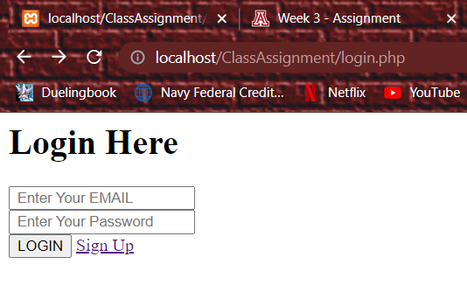

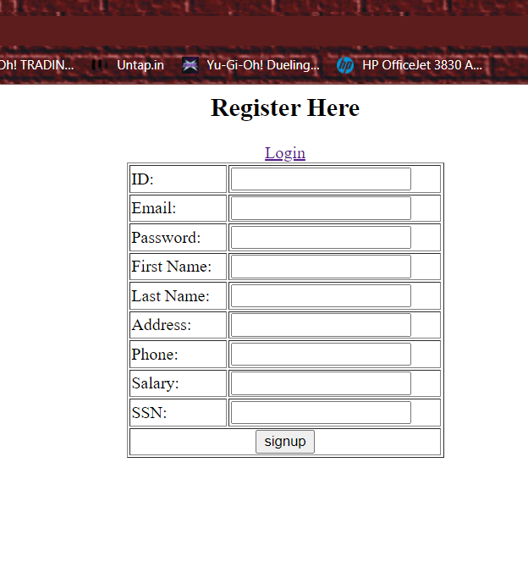

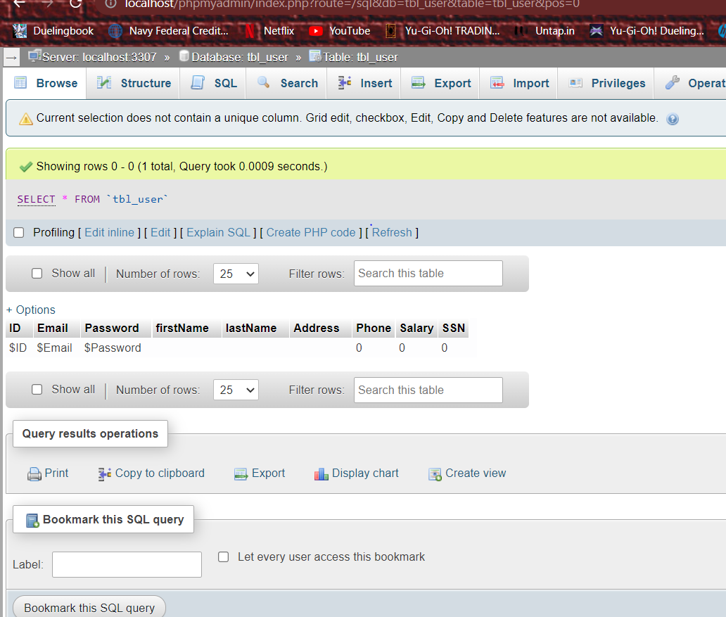

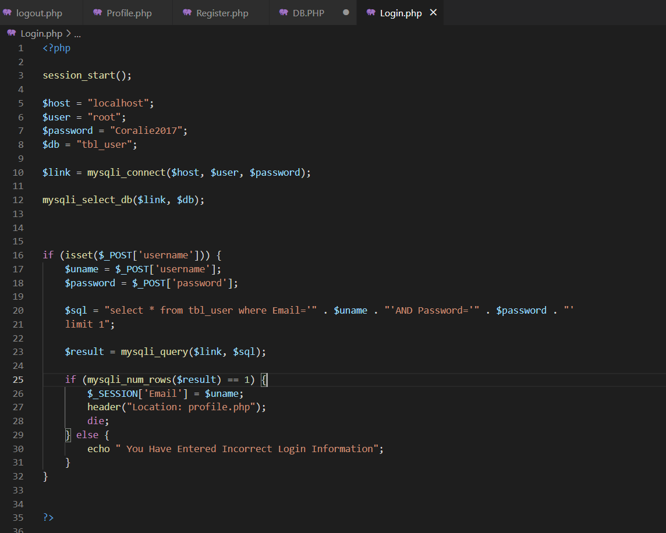  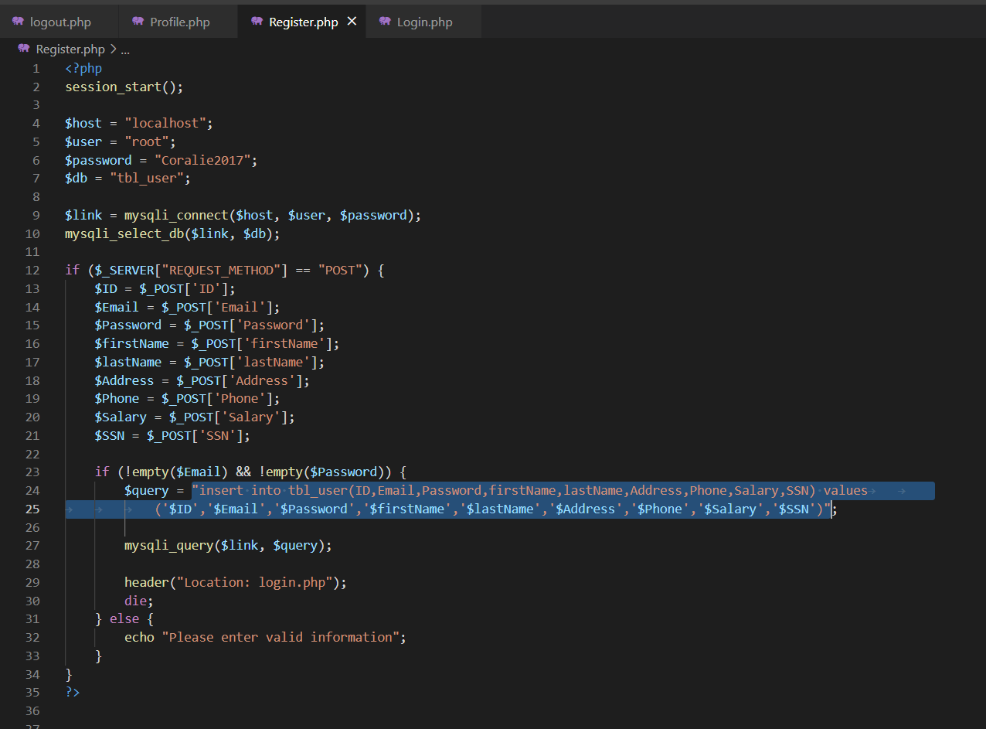 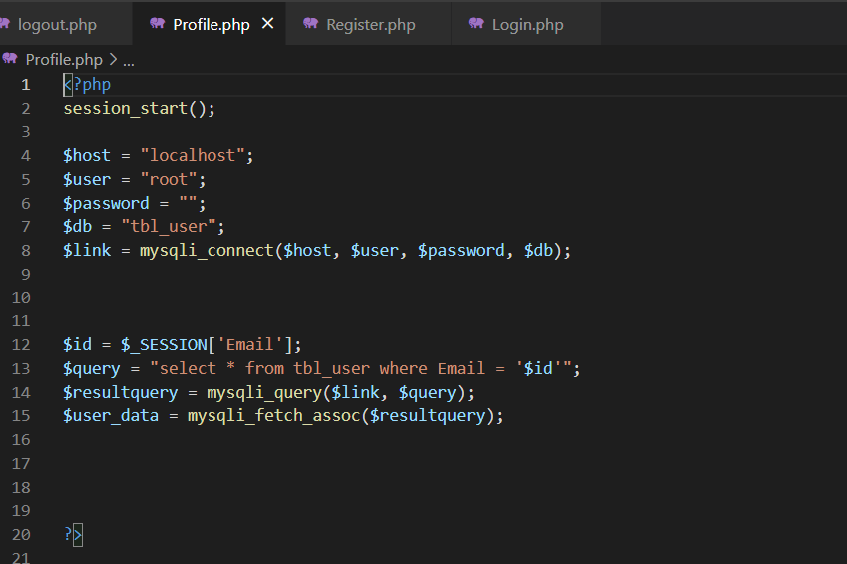

Sources

Tsui, F., Karam, O., & Bernal, B. (2018). Essentials of software engineering (4th ed.). Jones & Bartlett Learning.